# Proof Code runs:

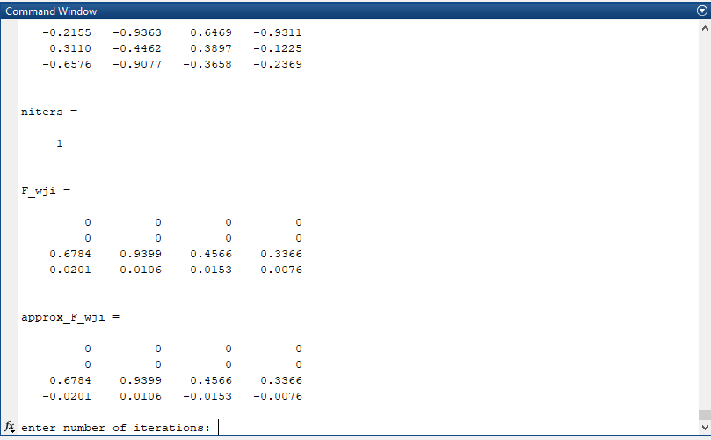

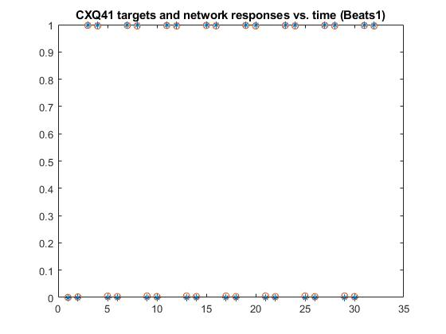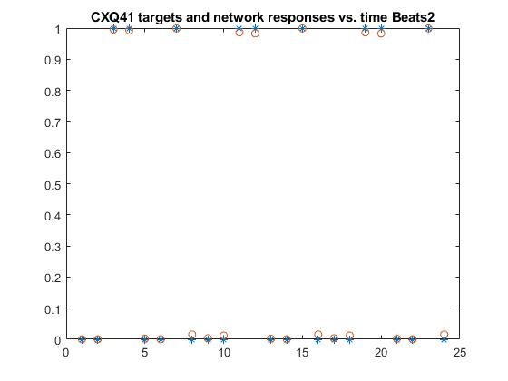

**Code are attached in zip and on GitHub.**

**Observation starts next page.**

# Observation

## Interneurons and convergence rate:

From observation, I found once after 100,000 runs, the RMS_error will reach a steady state. Therefore, all trials are run for 100,000 iterations. For plotting purposes, I reduced the amount of runs with the increase of interneurons so that I can complete this faster and not waste on duplicate values.

For Beats2, with interneuron quantity of 4, it won’t converge happily. The RMS Error hovers at above 0.15, while in comparison Beats1 converges.

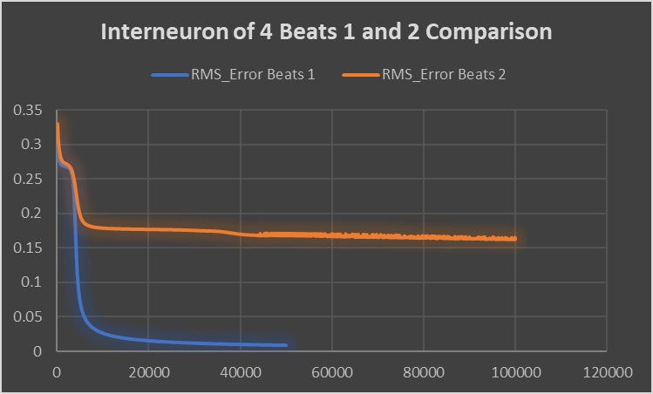

Starting from with 5 interneurons, we can see that beats2 starts to converge happily. Below is an example of 5 interneurons convergence: We can see that for beats 1, it converges faster than beats2.

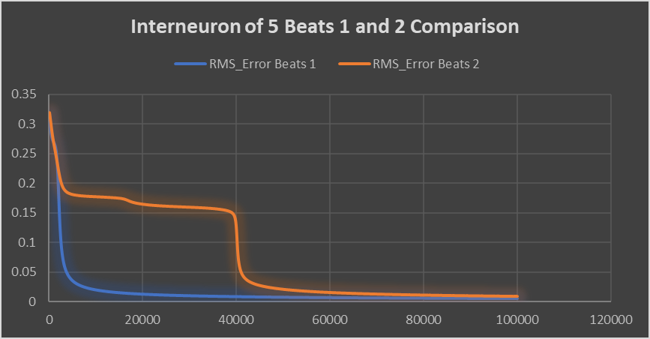

In order to make it clearer, when we plot logarithmically, we can see the details:

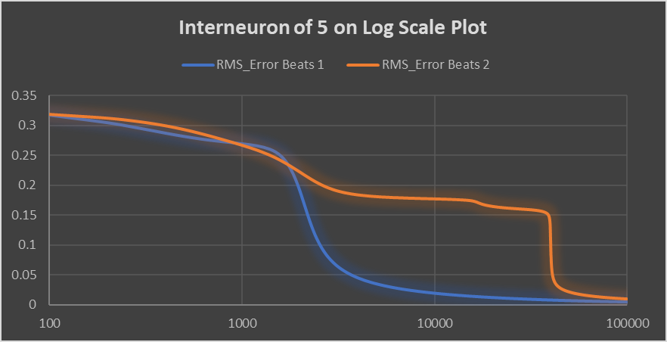

For the purpose of demonstration, we have tried 5 different interneuron numbers with beats2 to show the affect of interneurons and convergence. In short, the more interneurons the merrier (Faster Convergence rate).

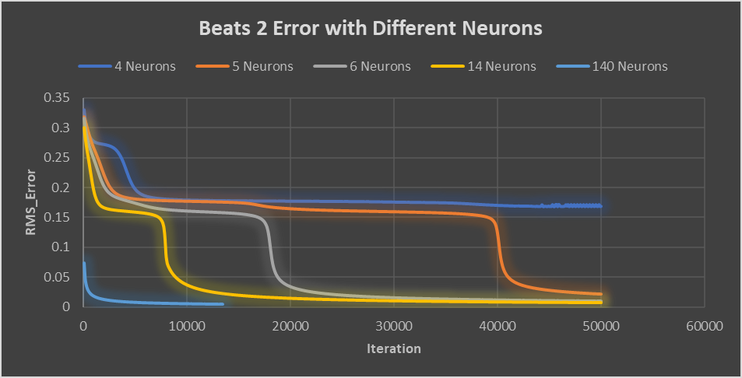

## Adaptive learning:

We implemented adaptive learning using code similar to problem set 2. Here is the code implemented inside figure generation loop:



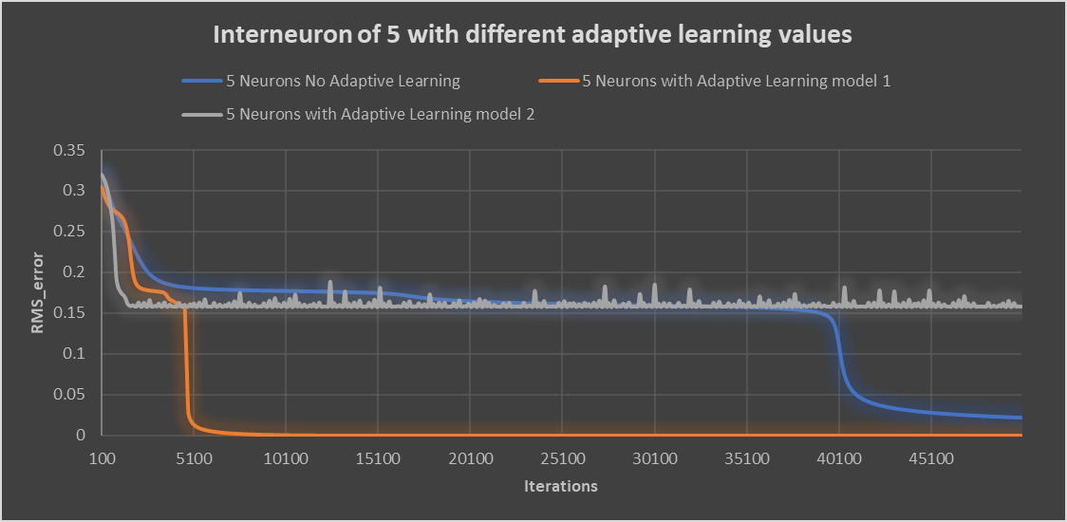

For above figure, we purposefully demoed two result of adaptive learning. Model 1 to be very conservative model where we have incrementation of 1.1 and 0.9, and model 2 to be very aggressive adaptive learning with incrementation to be 1.5 and 0.5.

With model 2, we can see the adaptive learning rate caused an instability in the system causing convergence issue, while more conservative value settings helped us to converge faster than without any adaptive learning rate.

## My own beats file!

So just on the purpose of having some fun, I modified the beats file and give the net a new problem to solve. With increase of interneurons, the system successfully works! The following net is run 100000 times, with 6 neurons. Since the system is more complicated compared to previous, therefore we might need more runs.

